Advanced Application Programming
CAT II
Wallace Wahong’o 20/03944 BSD

Design and Implement KCA Student result slip management system
class student
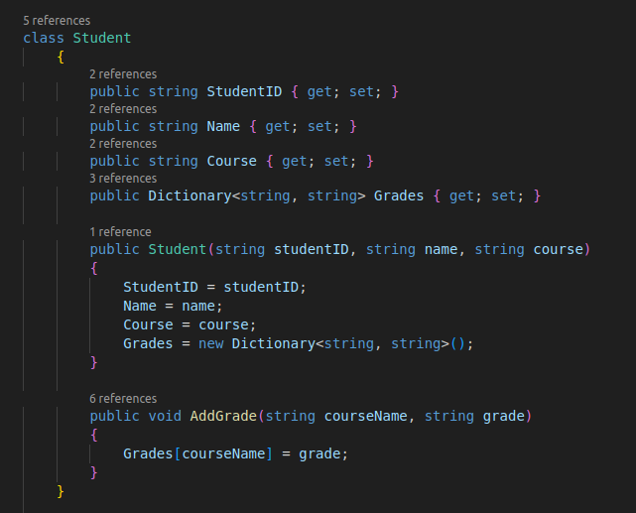
Properties: StudentID, Name, Course, Grade
methods: AddGrade() - add grade to the student.
class ResultSlip

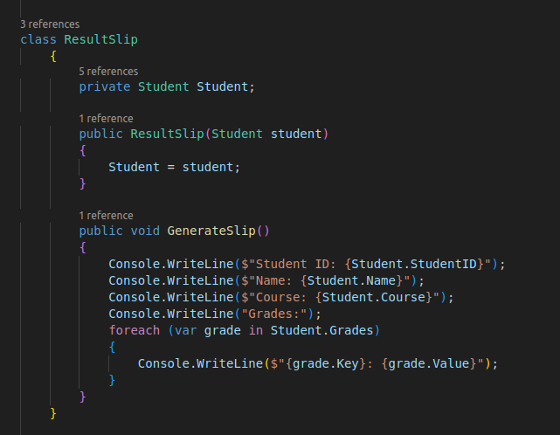
ResultSlip – constructor

GenerateSlip – prints the Students grade

